*Environmental sustainability*

**The European Green Deal and challenges for Ukraine**

**Petro Petrenko1*, Vasyl Vasylenko2**

*1National University of Food Technologies, Kyiv, Ukraine*

*2Taras Shevchenko National University of Kyiv, Ukraine*

*\*Corresponding author:* [*petrenko@gmail.com*](mailto:petrenko@gmail.com)

*Abstract: (200-250 words) text, abstract text, abstract text, abstract text, abstract text, abstract text, abstract text, abstract text, abstract text, abstract text, abstract text, abstract text, abstract text, abstract text, abstract text, abstract text, abstract text, abstract text, abstract text, abstract text, abstract text, abstract text, abstract text, abstract text, abstract text, abstract text.*

*Keywords: (3-5 keywords)*

|  |  |
| --- | --- |
|  |  |

**Introduction**

Text text text text text text text text text text text text text text text text text text text text text text text text text text text text text text text text text text text text text text text text text text text text text text text text text text text text text text text text text text text text text text text text text text text text text text text text text text text text text text text text text text text text text text text (Vadakkan et al., 2024). Text text text text text text text text text text text text text text text text text text text text text text text text text text text text text text text text text text text text text text text text text text text text text text text text text text text text text text text text text text text text text text text text text text text text text text text text text text text text text text text text text text text text text text text (Man et al., 2022).

Text text text text text text text text text text text text text text text text text text text text text text text text text text text text text text text text text text text text text text text text text text text text text text text text text text text text text text text text text text text text text text text text text text text text text text text text text text text text text text text text text text text text text text text text text text text text text text text text text text text text text text text text text text text text text text text text text text text text text text text text text text text text text text text text text text text text text text text text text text (Kovač et al., 2021), text (Aron, 2023; CIA, 2016).

**Materials and Methods (or other sections for a review article)**

*Design of the research*

Text text text text text text text text text text text text text text text text text text text text text ext text text text text text text text text text text text text text text text text text text text text text text text text text text text еext text text text text text text text text text text text text text text text text text text text text text text text.

*Chemicals*

Text text text text text text text text text text text text text text text text text text text text text ext text text text text text text text text text text text text text text text text text text text text text text text text text text text еext text text text text text text text text text text text text text text text text text text text text text text text.

*Samples*

Text text text text text text text text text text text text text text text text text text text text text ext text text text text text text text text text text text text text text text text text text text text text text text text text text text еext text text text text text text text text text text text text text text text text text text text text text text text.

*Equipment and conditions*

Text text text text text text text text text text text text text text text text text text text text text ext text text text text text text text text text text text text text text text text text text text text text text text text text text text еext text text text text text text text text text text text text text text text text text text text text text text text.

*Statistical analysis*

Text text text text text text text text text text text text text text text text text text text text text ext text text text text text text text text text text text text text text text text text text text text text text text text text text text еext text text text text text text text text text text text text text text text text text text text text text text text.

**Results and Discussion** **(or other sections for a review article)**

Text text text text text text text text text text (Table 1) text text text text text text text text text text text ext text text text text text text text text text text text text text text text text text text text text text text text text text text text еext text text text text text text text text text text text text text text text text text text text text text text text (Sivaraj et al., 2020).

**Table 1. Text text text text text text**

|  |  |  |  |
| --- | --- | --- | --- |
| Text | Text | Text | Text |
| Text | Text | Text | Text |
| Text | Text | Text | Text |
| Text | Text | Text | Text |

Text text text text text text text text text text text text text text text text text text text text text ext text text text text text text text text text text text text text text text text text text text text text text text text text text text еext text text text text text text text text text text text text text text text text text text text text text text text (Mustapha et al., 2022).

Text text text text text (Table 2) text text text text text text text text text text text text text text text text ext text text text text text text text text text text text text text text text text text text text text text text text text text text text еext text text text text text text text text text text text text text text text text text text text text text text text (Author et al., year).

Text text text text text (Figure 1) text text text text text text text text text text text text text text text text ext text text text text text text text text text text text text text text text text text text text text text text text text text text text еext text text text text text text text text text text text text text text text text text text text text text text text (Author et al., year).

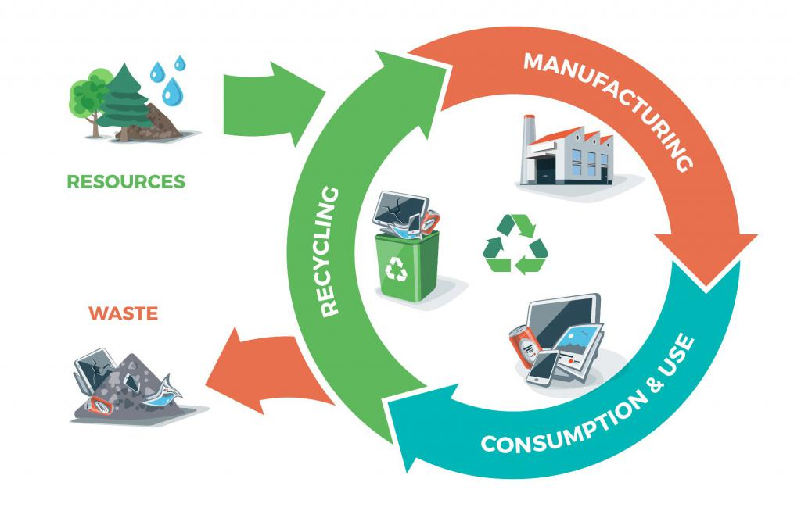

**Figure 1. The model of the EU circular economy (EP, 2023)**

Text text text text text text text text text text text text text text text text text text text text text ext text text text text text text text text text text text text text text text text text text text text text text text text text text text еext text text text text text text text text text text text text text text text text text text text text text text text (Author et al., year; Author et al., year).

Text text text text text text text text text text text text text text text text text text text text text ext text text text text text text text text text text text text text text text text text text text text text text text text text text text еext text text text text text text text text text text text text text text text text text text text text text text text (Author et al., year).

**Conclusions**

Text text text text text text text text text text text text text text text text text text text text text ext text text text text text text text text text text text text text text text text text text text text text text text text text text text еext text text text text text text text text text text text text text text text text text text text text text text text …..

**Acknowledgment**

Text text text text text …….

**Conflict of interest**

The authors state no conflict of interest.

**References**

Ahamad, I., Aziz, N., Zaki, A., & Fatma, T. (2021). Synthesis and characterization of silver nanoparticles using *Anabaena variabilis* as a potential antimicrobial agent. *Journal of Applied Phycology*, *33*, 829-841. <https://doi.org/10.1007/s10811-020-02323-w>

Aron, A. (2023). The climate crisis: science, impacts, policy, psychology, justice, social movements. Cambridge, United Kingdom: Cambridge University Press.

CIA (2016). The World Factbook – Central Intelligence Agency. Available at www.cia.gov. Retrieved 13 October 2016.

EP. (2023). Circular economy: Definition, importance and benefits

Hanna, A. L., Hamouda, H. M., Goda, H. A., Sadik, M. W., Moghanm, F. S., Ghoneim, A. M., ... & Elsayed, T. R. (2022). Biosynthesis and characterization of silver nanoparticles produced by *Phormidium ambiguum* and *Desertifilum tharense* cyanobacteria. *Bioinorganic Chemistry and Applications*, *2022*(1), 9072508. <https://doi.org/10.1155/2022/9072508>

Ismail, G. A., El-Sheekh, M. M., Samy, R. M., & Gheda, S. F. (2021). Antimicrobial, antioxidant, and antiviral activities of biosynthesized silver nanoparticles by phycobiliprotein crude extract of the cyanobacteria *Spirulina platensis* and *Nostoc linckia*. *Bionanoscience*, *11*, 355-370. <https://doi.org/10.1007/s12668-021-00828-3>

Kovač, A., Paranos, M., & Marciuš, D. (2021). Hydrogen in energy transition: A review. *International Journal of Hydrogen Energy*, *46*(16), 10016-10035. <https://doi.org/10.1016/j.ijhydene.2020.11.256>

Man, Y., Xu, T., Adhikari, B., Zhou, C., Wang, Y., & Wang, B. (2022). Iron supplementation and iron-fortified foods: a review. *Critical Reviews in Food Science and Nutrition*, *62*(16), 4504-4525. <https://doi.org/10.1080/10408398.2021.1876623>

Mustapha, T., Misni, N., Ithnin, N. R., Daskum, A. M., & Unyah, N. Z. (2022). A review on plants and microorganisms mediated synthesis of silver nanoparticles, role of plants metabolites and applications. *International Journal of Environmental Research and Public Health*, *19*(2), 674. <https://doi.org/10.3390/ijerph19020674>

Sivaraj, A., Kumar, V., Sunder, R., Parthasarathy, K., & Kasivelu, G. (2020). Commercial yeast extracts mediated green synthesis of silver chloride nanoparticles and their anti-mycobacterial activity. *Journal of Cluster Science*, *31*, 287-291. <https://doi.org/10.1007/s10876-019-01626-4>

Vadakkan, K., Rumjit, N. P., Ngangbam, A. K., Vijayanand, S., & Nedumpillil, N. K. (2024). Novel advancements in the sustainable green synthesis approach of silver nanoparticles (AgNPs) for antibacterial therapeutic applications. *Coordination Chemistry Reviews*, *499*, 215528. <https://doi.org/10.1016/j.ccr.2023.21552>

Younis, N. S., Mohamed, M. E., El Semary N. A. (2022) Green synthesis of silver nanoparticles by the cyanobacteria *Synechocystis* sp.: characterization, antimicrobial and diabetic wound-healing actions. *Mar. Drugs*, 20(1), 56. doi: 10.3390/md20010056.

Younis, N. S., Mohamed, M. E., & El Semary, N. A. (2022). Green synthesis of silver nanoparticles by the cyanobacteria *Synechocystis* sp.: characterization, antimicrobial and diabetic wound-healing actions. *Marine Drugs*, *20*(1), 56. <https://doi.org/10.3390/md20010056>

Zaki, A., Aziz, M. N., Ahmad, R., Ahamad, I., Ali, M. S., Yasin, D., ... & Fatma, T. (2022). Synthesis, purification and characterization of *Plectonema* derived AgNPs with elucidation of the role of protein in nanoparticle stabilization. *RSC advances*, *12*(4), 2497-2510. <https://doi.org/10.1039/D1RA08396A>